Spot the pattern

Think/write/pair/share
Can you see any repetition and/or patterns in the following program?

Code | Answer▿
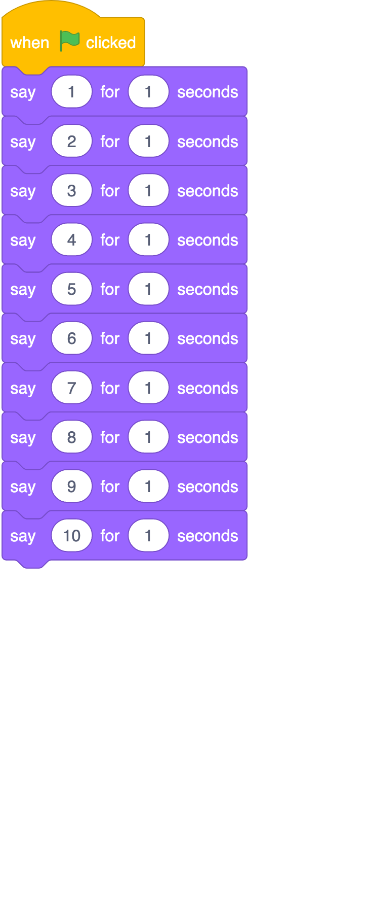

Resources are updated regularly — the latest version is available at: ncce.io/tcc.

This resource is licensed under the Open Government Licence, version 3. For more information on this licence, see ncce.io/ogl.

