**Transition to Sixth Form**

The following worksheets cover work that would usually be grade 9 – 7 at IGCSE. Students wishing to following Maths in the Sixth (A level or IB) should be able to access all the work in these worksheets

1. Surds
2. Indices
3. Rearranging Formulae
4. Algebraic Fractions
5. Using Graphs
6. Quadratic Equations
7. Simultaneous Equations
8. Algebraic Proofs
9. Trigonometry – for triangles which are not right-angled
10. Tree Diagrams
11. Mixed Questions

**1. Surds**

[i]

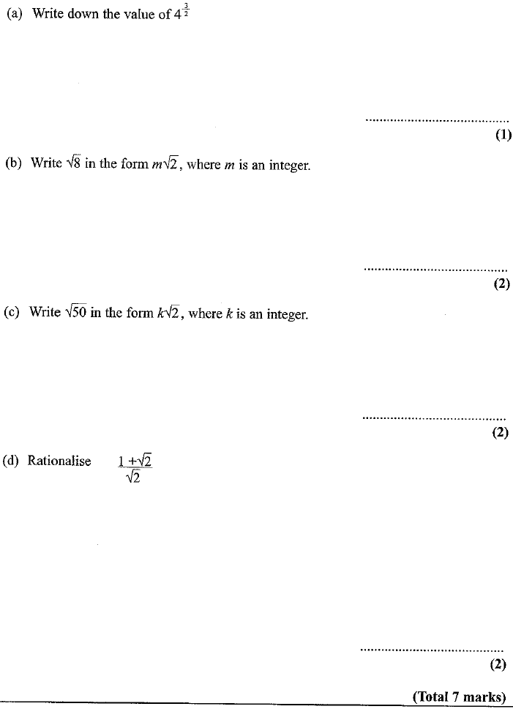

[ii]

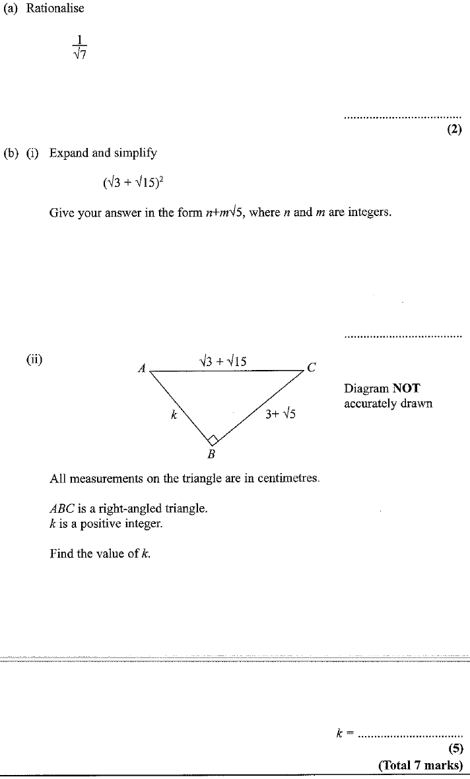

**2. Indices**

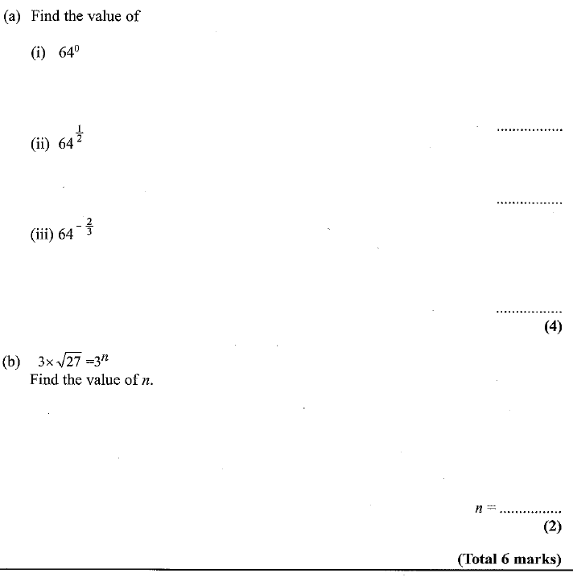

**3. Rearranging Formulae**

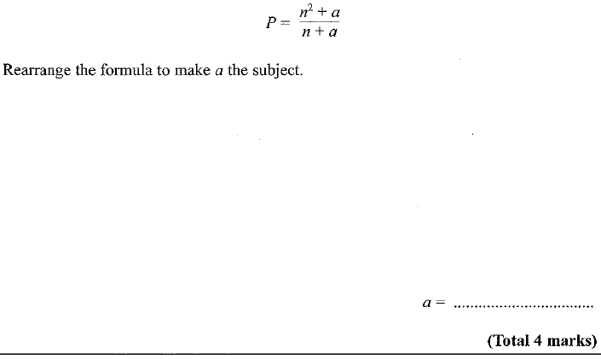

**4. Algebraic Fractions**

(i)

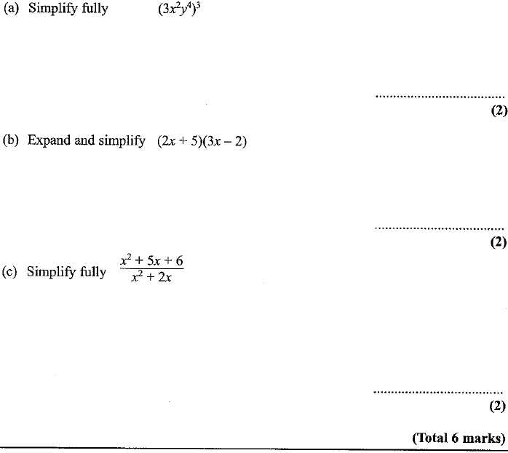

(ii)

**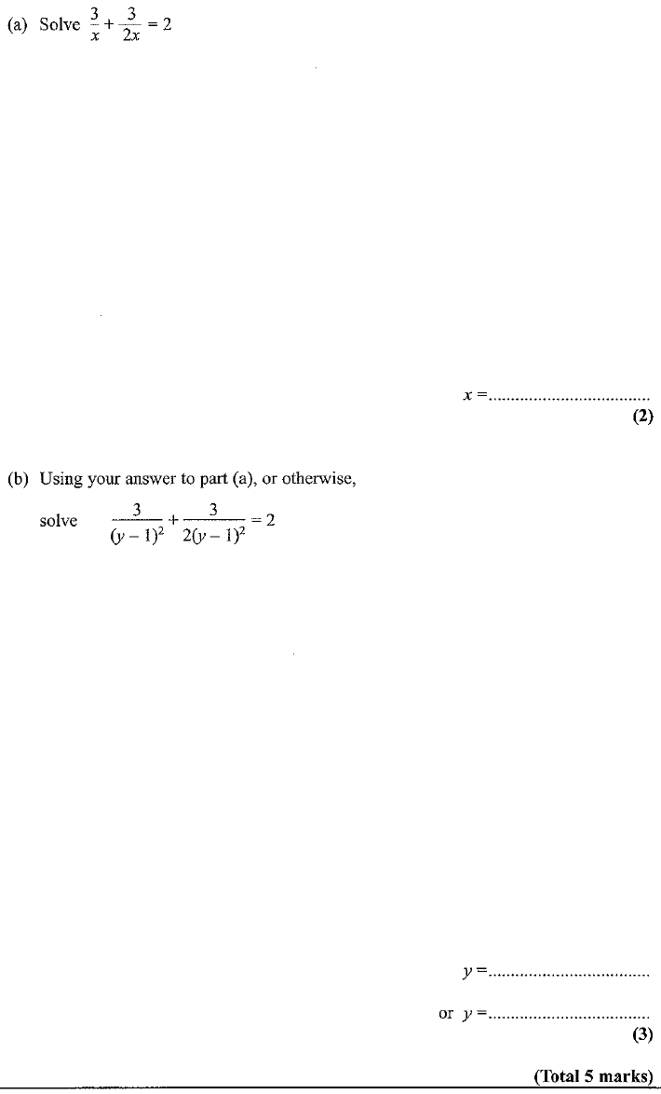****5. Using Graphs**

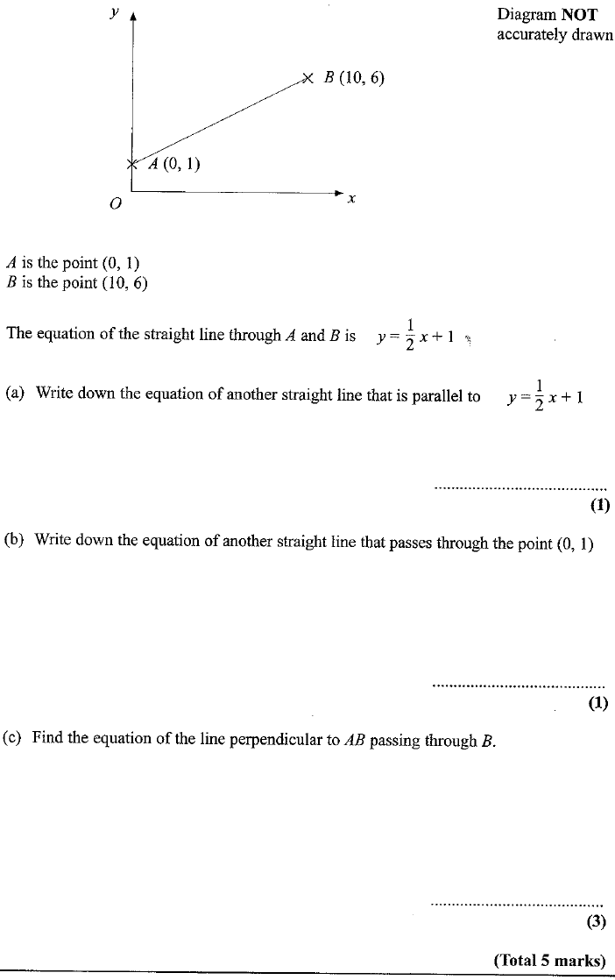

**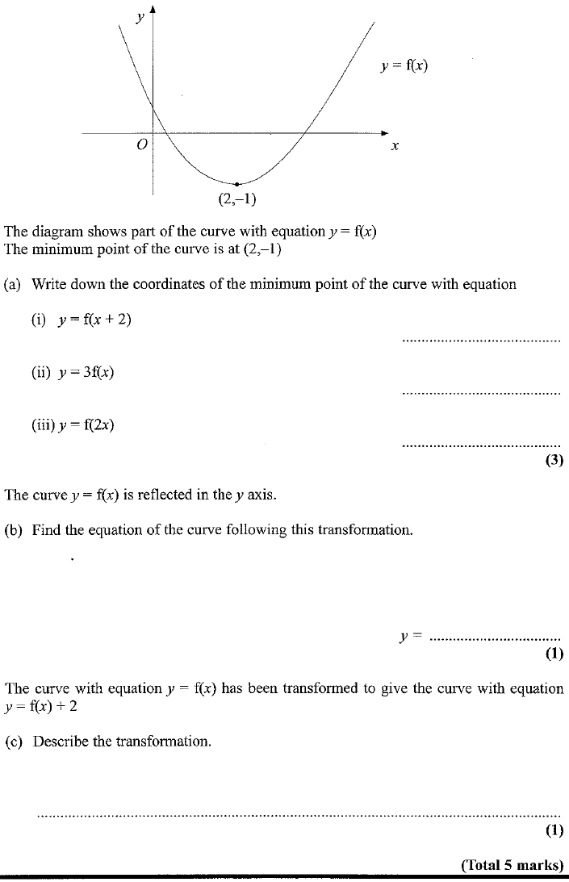****6. Quadratic Equations**

(i) 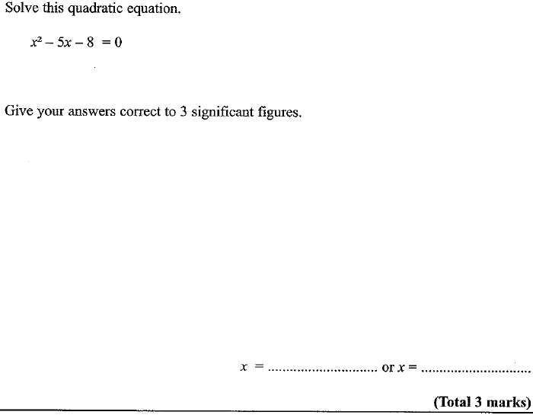

**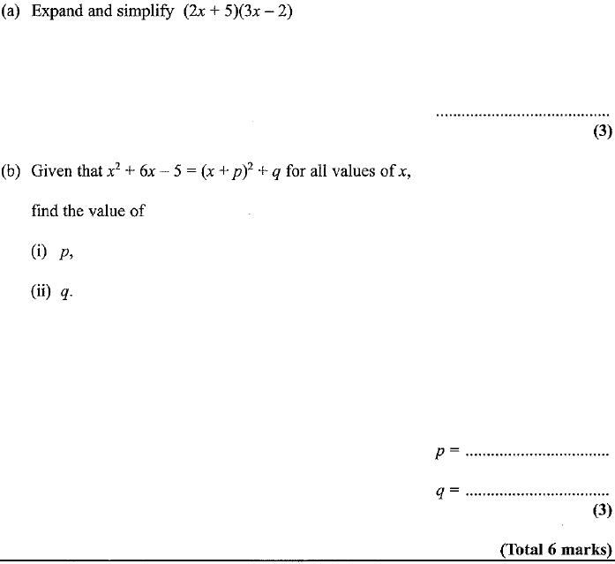 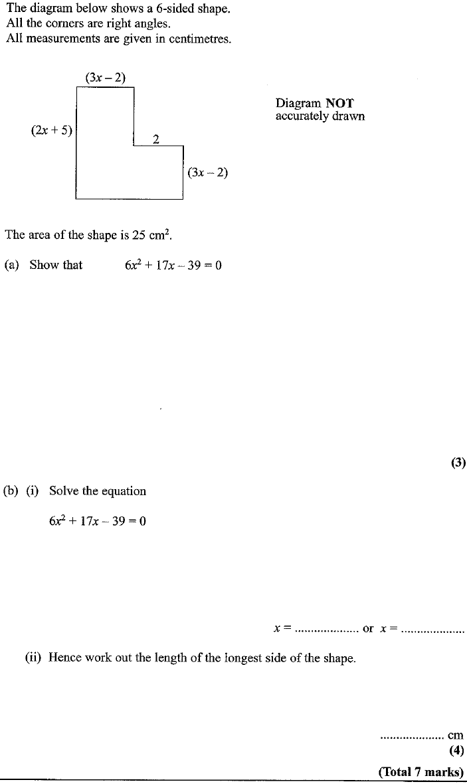****7. Simultaneous Equations**

(i)

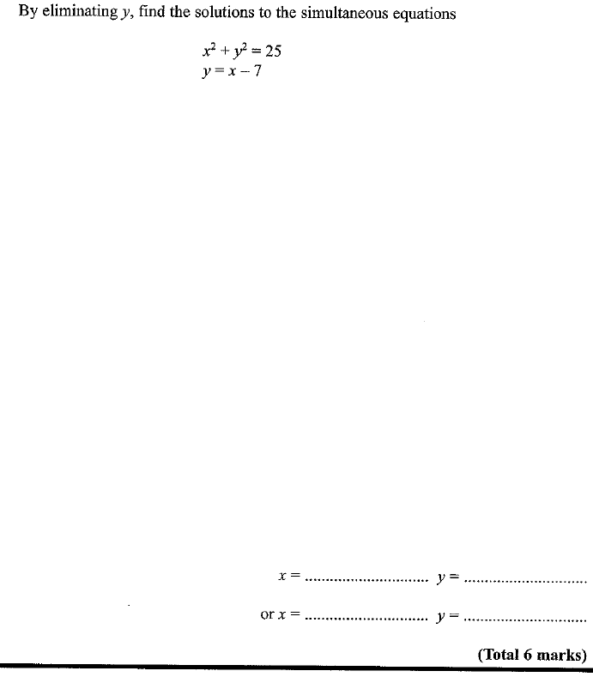

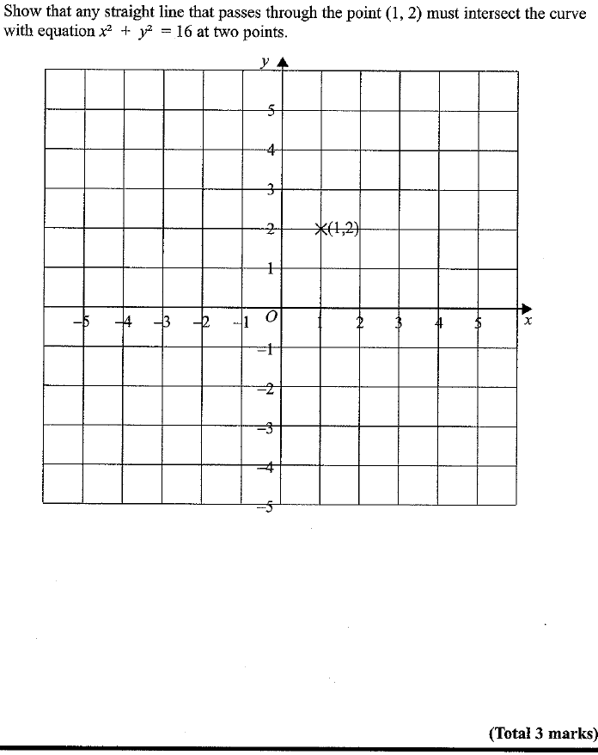8. Algebraic Proofs

[i]

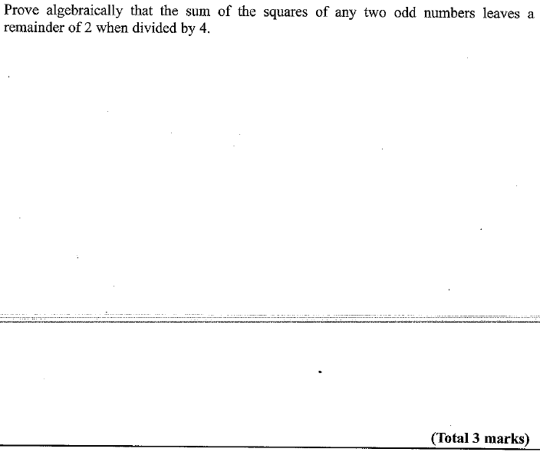

[ii]

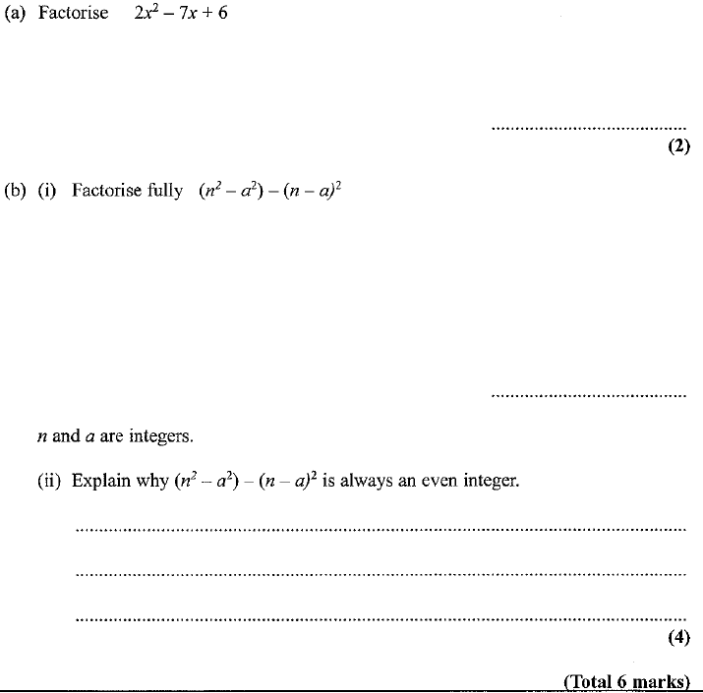

[iii]

(*a*) Write down an expression, in terms of *n*, for the *n*th multiple of 5.

.............................

**(1)**

(*b*) Hence or otherwise

(i) prove that the sum of two consecutive multiples of 5 is always an odd number,

(ii) prove that the product of two consecutive multiples of 5 is always an even number.

(**5)**

**(Total 6 marks)**

**9. Trigonometry**

[i]

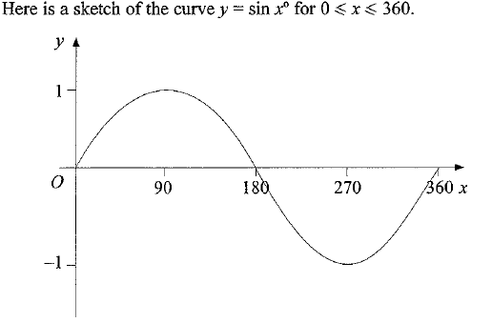

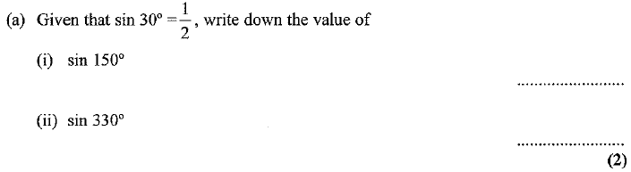

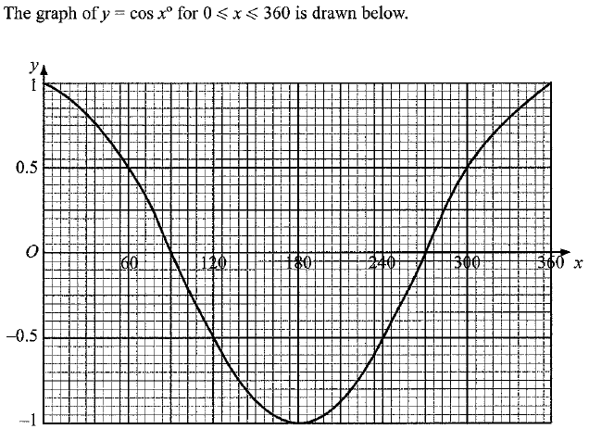

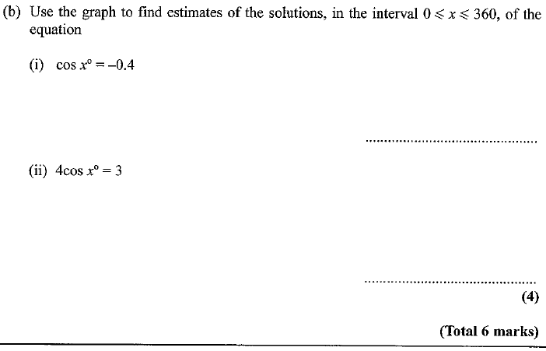

[iii]

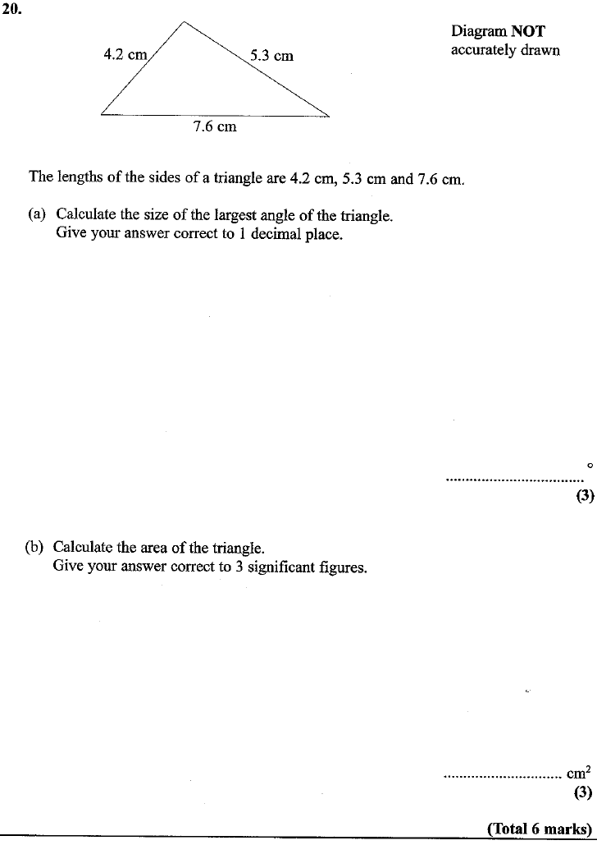

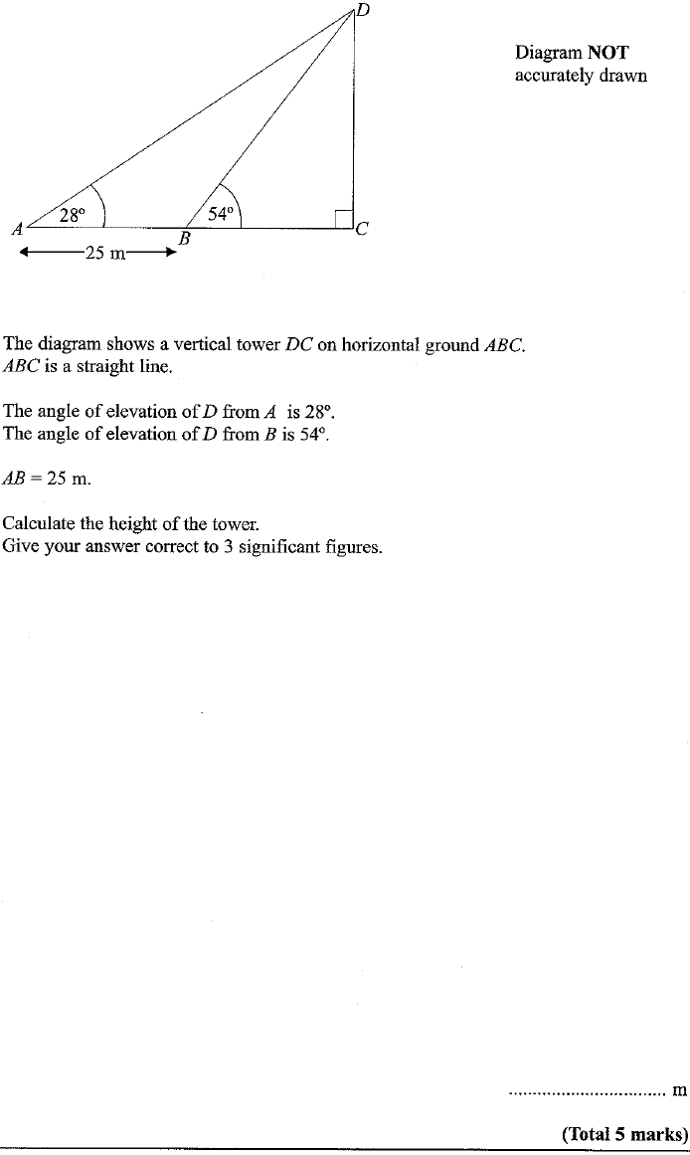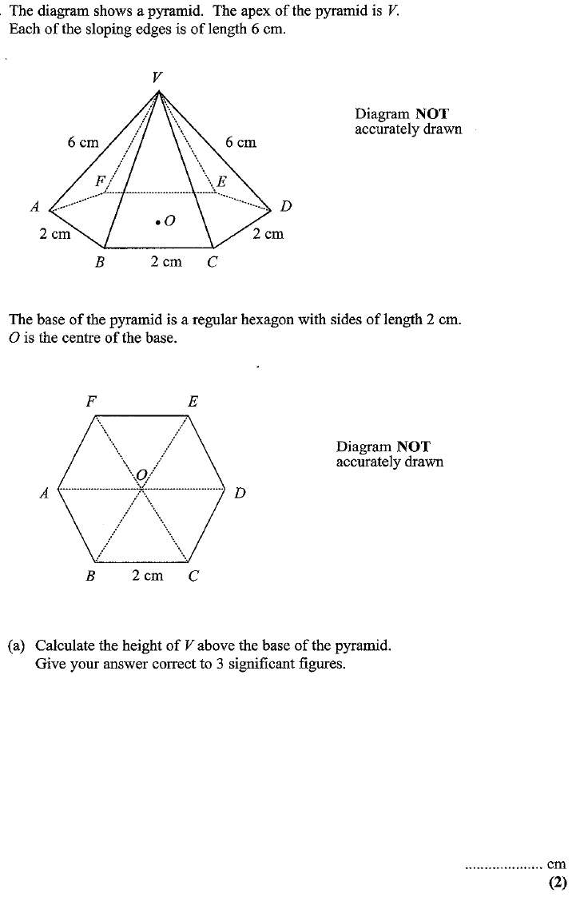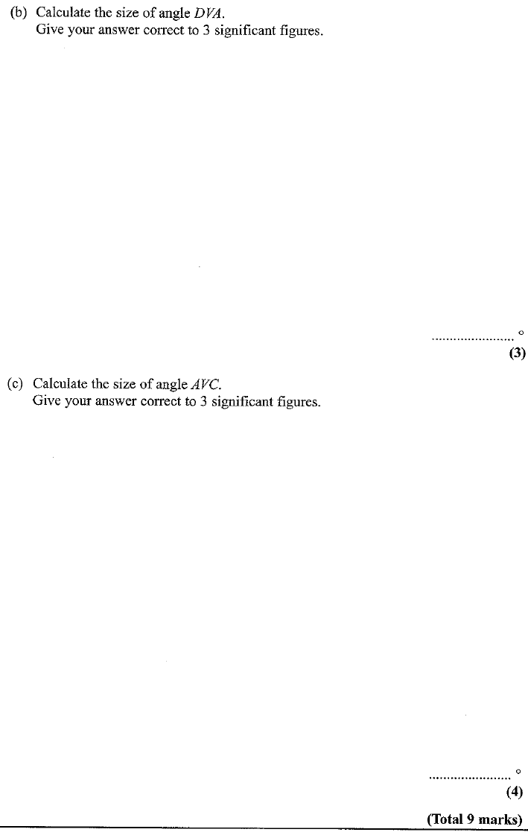

**10. Tree Diagrams**

[i]

Joan has two boxes of chocolates.

The boxes are labelled **A** and **B**.

Box **A** contains 15 chocolates. There are 6 plain, 4 milk and 5 white chocolates.

Box **B** contains 12 chocolates. There are 4 plain, 3 milk and 5 white chocolates.

Joan takes one chocolate at random from each box.

Work out the probability that the two chocolates Joan takes are not of the same type.

………………………………

**(4)**

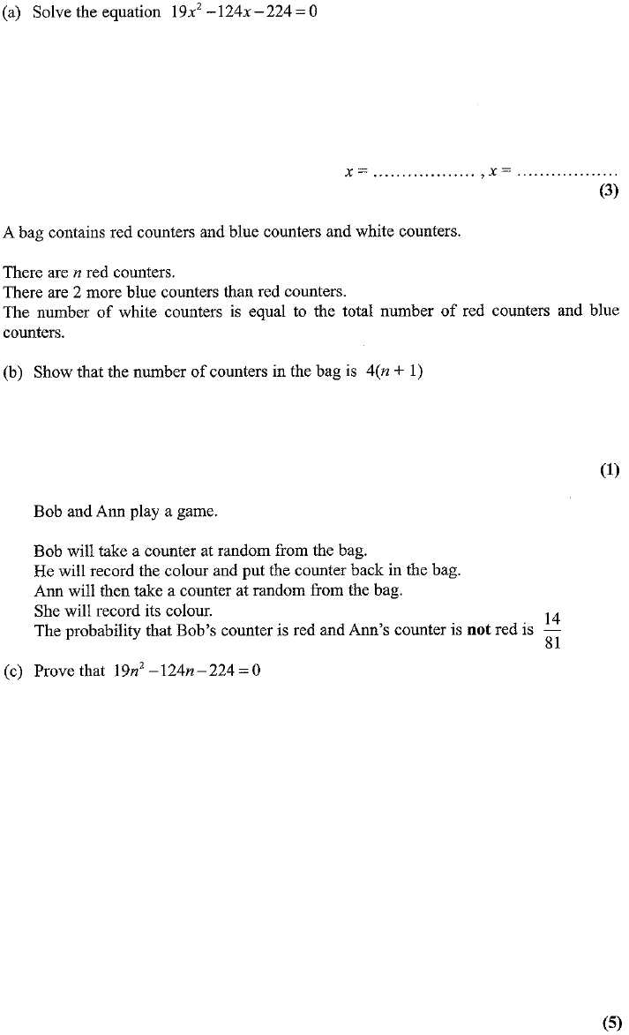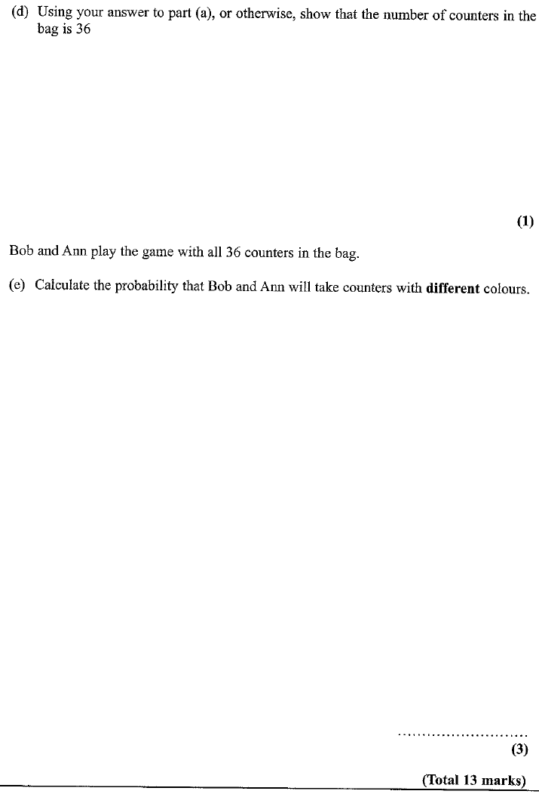

**11. Mixed Questions**

The depth, *D* metres, of the water at the end of a jetty in the afternoon can be modelled by this formula

*D* = 5.5 + *A* sin 30(*t* – *k*)°

where

*t* hours is the number of hours after midday,

*A* and *k* are constants.

Yesterday the low tide was at 3 p.m.

The depth of water at low tide was 3.5 m.

Find the value of *A* and *k*.

*A* = ………………………

*k* = ………………………

**(4)**

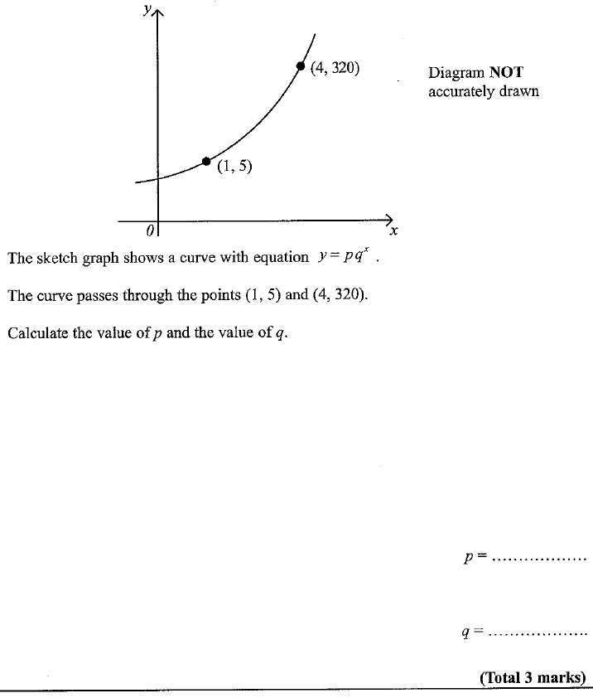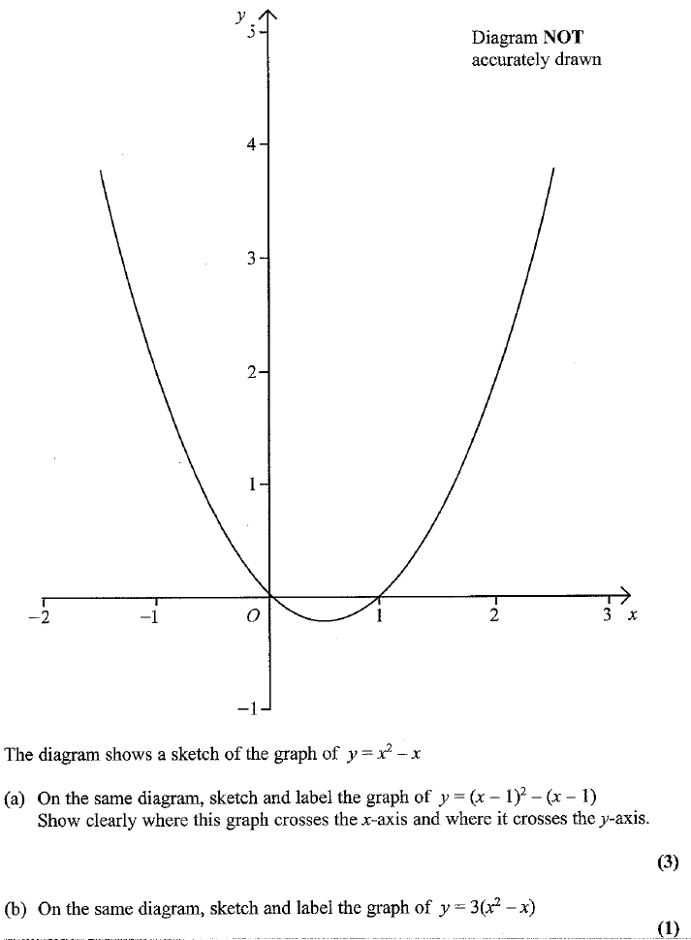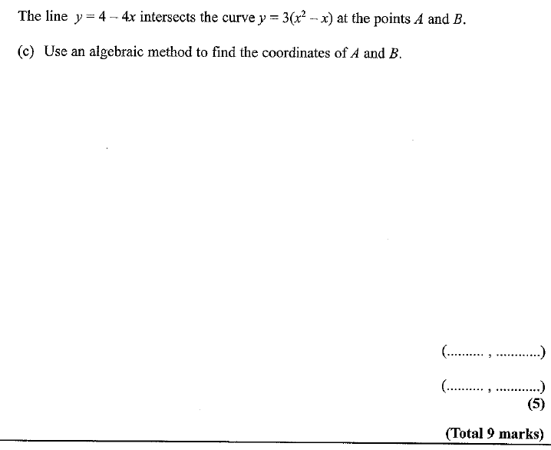

*y*

*x*

8

4

–4

–12

–8

–4

12

6

4

12

*O*

–8

–12

|  |  |  |  |  |  |  |  |  |  |  |  |  |  |  |  |  |  |  |  |  |  |  |  |  |  |  |  |  |  |  |  |  |  |  |  |  |  |  |  |  |  |  |  |  |  |  |  |  |  |  |  |  |  |  |  |  |  |  |  |
| --- | --- | --- | --- | --- | --- | --- | --- | --- | --- | --- | --- | --- | --- | --- | --- | --- | --- | --- | --- | --- | --- | --- | --- | --- | --- | --- | --- | --- | --- | --- | --- | --- | --- | --- | --- | --- | --- | --- | --- | --- | --- | --- | --- | --- | --- | --- | --- | --- | --- | --- | --- | --- | --- | --- | --- | --- | --- | --- | --- |
|  |  |  |  |  |  |  |  |  |  |  |  |  |  |  |  |  |  |  |  |  |  |  |  |  |  |  |  |  |  |  |  |  |  |  |  |  |  |  |  |  |  |  |  |  |  |  |  |  |  |  |  |  |  |  |  |  |  |  |  |
|  |  |  |  |  |  |  |  |  |  |  |  |  |  |  |  |  |  |  |  |  |  |  |  |  |  |  |  |  |  |  |  |  |  |  |  |  |  |  |  |  |  |  |  |  |  |  |  |  |  |  |  |  |  |  |  |  |  |  |  |
|  |  |  |  |  |  |  |  |  |  |  |  |  |  |  |  |  |  |  |  |  |  |  |  |  |  |  |  |  |  |  |  |  |  |  |  |  |  |  |  |  |  |  |  |  |  |  |  |  |  |  |  |  |  |  |  |  |  |  |  |
|  |  |  |  |  |  |  |  |  |  |  |  |  |  |  |  |  |  |  |  |  |  |  |  |  |  |  |  |  |  |  |  |  |  |  |  |  |  |  |  |  |  |  |  |  |  |  |  |  |  |  |  |  |  |  |  |  |  |  |  |
|  |  |  |  |  |  |  |  |  |  |  |  |  |  |  |  |  |  |  |  |  |  |  |  |  |  |  |  |  |  |  |  |  |  |  |  |  |  |  |  |  |  |  |  |  |  |  |  |  |  |  |  |  |  |  |  |  |  |  |  |
|  |  |  |  |  |  |  |  |  |  |  |  |  |  |  |  |  |  |  |  |  |  |  |  |  |  |  |  |  |  |  |  |  |  |  |  |  |  |  |  |  |  |  |  |  |  |  |  |  |  |  |  |  |  |  |  |  |  |  |  |
|  |  |  |  |  |  |  |  |  |  |  |  |  |  |  |  |  |  |  |  |  |  |  |  |  |  |  |  |  |  |  |  |  |  |  |  |  |  |  |  |  |  |  |  |  |  |  |  |  |  |  |  |  |  |  |  |  |  |  |  |
|  |  |  |  |  |  |  |  |  |  |  |  |  |  |  |  |  |  |  |  |  |  |  |  |  |  |  |  |  |  |  |  |  |  |  |  |  |  |  |  |  |  |  |  |  |  |  |  |  |  |  |  |  |  |  |  |  |  |  |  |
|  |  |  |  |  |  |  |  |  |  |  |  |  |  |  |  |  |  |  |  |  |  |  |  |  |  |  |  |  |  |  |  |  |  |  |  |  |  |  |  |  |  |  |  |  |  |  |  |  |  |  |  |  |  |  |  |  |  |  |  |
|  |  |  |  |  |  |  |  |  |  |  |  |  |  |  |  |  |  |  |  |  |  |  |  |  |  |  |  |  |  |  |  |  |  |  |  |  |  |  |  |  |  |  |  |  |  |  |  |  |  |  |  |  |  |  |  |  |  |  |  |
|  |  |  |  |  |  |  |  |  |  |  |  |  |  |  |  |  |  |  |  |  |  |  |  |  |  |  |  |  |  |  |  |  |  |  |  |  |  |  |  |  |  |  |  |  |  |  |  |  |  |  |  |  |  |  |  |  |  |  |  |
|  |  |  |  |  |  |  |  |  |  |  |  |  |  |  |  |  |  |  |  |  |  |  |  |  |  |  |  |  |  |  |  |  |  |  |  |  |  |  |  |  |  |  |  |  |  |  |  |  |  |  |  |  |  |  |  |  |  |  |  |
|  |  |  |  |  |  |  |  |  |  |  |  |  |  |  |  |  |  |  |  |  |  |  |  |  |  |  |  |  |  |  |  |  |  |  |  |  |  |  |  |  |  |  |  |  |  |  |  |  |  |  |  |  |  |  |  |  |  |  |  |
|  |  |  |  |  |  |  |  |  |  |  |  |  |  |  |  |  |  |  |  |  |  |  |  |  |  |  |  |  |  |  |  |  |  |  |  |  |  |  |  |  |  |  |  |  |  |  |  |  |  |  |  |  |  |  |  |  |  |  |  |
|  |  |  |  |  |  |  |  |  |  |  |  |  |  |  |  |  |  |  |  |  |  |  |  |  |  |  |  |  |  |  |  |  |  |  |  |  |  |  |  |  |  |  |  |  |  |  |  |  |  |  |  |  |  |  |  |  |  |  |  |
|  |  |  |  |  |  |  |  |  |  |  |  |  |  |  |  |  |  |  |  |  |  |  |  |  |  |  |  |  |  |  |  |  |  |  |  |  |  |  |  |  |  |  |  |  |  |  |  |  |  |  |  |  |  |  |  |  |  |  |  |
|  |  |  |  |  |  |  |  |  |  |  |  |  |  |  |  |  |  |  |  |  |  |  |  |  |  |  |  |  |  |  |  |  |  |  |  |  |  |  |  |  |  |  |  |  |  |  |  |  |  |  |  |  |  |  |  |  |  |  |  |
|  |  |  |  |  |  |  |  |  |  |  |  |  |  |  |  |  |  |  |  |  |  |  |  |  |  |  |  |  |  |  |  |  |  |  |  |  |  |  |  |  |  |  |  |  |  |  |  |  |  |  |  |  |  |  |  |  |  |  |  |
|  |  |  |  |  |  |  |  |  |  |  |  |  |  |  |  |  |  |  |  |  |  |  |  |  |  |  |  |  |  |  |  |  |  |  |  |  |  |  |  |  |  |  |  |  |  |  |  |  |  |  |  |  |  |  |  |  |  |  |  |
|  |  |  |  |  |  |  |  |  |  |  |  |  |  |  |  |  |  |  |  |  |  |  |  |  |  |  |  |  |  |  |  |  |  |  |  |  |  |  |  |  |  |  |  |  |  |  |  |  |  |  |  |  |  |  |  |  |  |  |  |
|  |  |  |  |  |  |  |  |  |  |  |  |  |  |  |  |  |  |  |  |  |  |  |  |  |  |  |  |  |  |  |  |  |  |  |  |  |  |  |  |  |  |  |  |  |  |  |  |  |  |  |  |  |  |  |  |  |  |  |  |
|  |  |  |  |  |  |  |  |  |  |  |  |  |  |  |  |  |  |  |  |  |  |  |  |  |  |  |  |  |  |  |  |  |  |  |  |  |  |  |  |  |  |  |  |  |  |  |  |  |  |  |  |  |  |  |  |  |  |  |  |
|  |  |  |  |  |  |  |  |  |  |  |  |  |  |  |  |  |  |  |  |  |  |  |  |  |  |  |  |  |  |  |  |  |  |  |  |  |  |  |  |  |  |  |  |  |  |  |  |  |  |  |  |  |  |  |  |  |  |  |  |
|  |  |  |  |  |  |  |  |  |  |  |  |  |  |  |  |  |  |  |  |  |  |  |  |  |  |  |  |  |  |  |  |  |  |  |  |  |  |  |  |  |  |  |  |  |  |  |  |  |  |  |  |  |  |  |  |  |  |  |  |
|  |  |  |  |  |  |  |  |  |  |  |  |  |  |  |  |  |  |  |  |  |  |  |  |  |  |  |  |  |  |  |  |  |  |  |  |  |  |  |  |  |  |  |  |  |  |  |  |  |  |  |  |  |  |  |  |  |  |  |  |
|  |  |  |  |  |  |  |  |  |  |  |  |  |  |  |  |  |  |  |  |  |  |  |  |  |  |  |  |  |  |  |  |  |  |  |  |  |  |  |  |  |  |  |  |  |  |  |  |  |  |  |  |  |  |  |  |  |  |  |  |
|  |  |  |  |  |  |  |  |  |  |  |  |  |  |  |  |  |  |  |  |  |  |  |  |  |  |  |  |  |  |  |  |  |  |  |  |  |  |  |  |  |  |  |  |  |  |  |  |  |  |  |  |  |  |  |  |  |  |  |  |
|  |  |  |  |  |  |  |  |  |  |  |  |  |  |  |  |  |  |  |  |  |  |  |  |  |  |  |  |  |  |  |  |  |  |  |  |  |  |  |  |  |  |  |  |  |  |  |  |  |  |  |  |  |  |  |  |  |  |  |  |
|  |  |  |  |  |  |  |  |  |  |  |  |  |  |  |  |  |  |  |  |  |  |  |  |  |  |  |  |  |  |  |  |  |  |  |  |  |  |  |  |  |  |  |  |  |  |  |  |  |  |  |  |  |  |  |  |  |  |  |  |
|  |  |  |  |  |  |  |  |  |  |  |  |  |  |  |  |  |  |  |  |  |  |  |  |  |  |  |  |  |  |  |  |  |  |  |  |  |  |  |  |  |  |  |  |  |  |  |  |  |  |  |  |  |  |  |  |  |  |  |  |
|  |  |  |  |  |  |  |  |  |  |  |  |  |  |  |  |  |  |  |  |  |  |  |  |  |  |  |  |  |  |  |  |  |  |  |  |  |  |  |  |  |  |  |  |  |  |  |  |  |  |  |  |  |  |  |  |  |  |  |  |
|  |  |  |  |  |  |  |  |  |  |  |  |  |  |  |  |  |  |  |  |  |  |  |  |  |  |  |  |  |  |  |  |  |  |  |  |  |  |  |  |  |  |  |  |  |  |  |  |  |  |  |  |  |  |  |  |  |  |  |  |
|  |  |  |  |  |  |  |  |  |  |  |  |  |  |  |  |  |  |  |  |  |  |  |  |  |  |  |  |  |  |  |  |  |  |  |  |  |  |  |  |  |  |  |  |  |  |  |  |  |  |  |  |  |  |  |  |  |  |  |  |
|  |  |  |  |  |  |  |  |  |  |  |  |  |  |  |  |  |  |  |  |  |  |  |  |  |  |  |  |  |  |  |  |  |  |  |  |  |  |  |  |  |  |  |  |  |  |  |  |  |  |  |  |  |  |  |  |  |  |  |  |
|  |  |  |  |  |  |  |  |  |  |  |  |  |  |  |  |  |  |  |  |  |  |  |  |  |  |  |  |  |  |  |  |  |  |  |  |  |  |  |  |  |  |  |  |  |  |  |  |  |  |  |  |  |  |  |  |  |  |  |  |
|  |  |  |  |  |  |  |  |  |  |  |  |  |  |  |  |  |  |  |  |  |  |  |  |  |  |  |  |  |  |  |  |  |  |  |  |  |  |  |  |  |  |  |  |  |  |  |  |  |  |  |  |  |  |  |  |  |  |  |  |
|  |  |  |  |  |  |  |  |  |  |  |  |  |  |  |  |  |  |  |  |  |  |  |  |  |  |  |  |  |  |  |  |  |  |  |  |  |  |  |  |  |  |  |  |  |  |  |  |  |  |  |  |  |  |  |  |  |  |  |  |
|  |  |  |  |  |  |  |  |  |  |  |  |  |  |  |  |  |  |  |  |  |  |  |  |  |  |  |  |  |  |  |  |  |  |  |  |  |  |  |  |  |  |  |  |  |  |  |  |  |  |  |  |  |  |  |  |  |  |  |  |
|  |  |  |  |  |  |  |  |  |  |  |  |  |  |  |  |  |  |  |  |  |  |  |  |  |  |  |  |  |  |  |  |  |  |  |  |  |  |  |  |  |  |  |  |  |  |  |  |  |  |  |  |  |  |  |  |  |  |  |  |
|  |  |  |  |  |  |  |  |  |  |  |  |  |  |  |  |  |  |  |  |  |  |  |  |  |  |  |  |  |  |  |  |  |  |  |  |  |  |  |  |  |  |  |  |  |  |  |  |  |  |  |  |  |  |  |  |  |  |  |  |
|  |  |  |  |  |  |  |  |  |  |  |  |  |  |  |  |  |  |  |  |  |  |  |  |  |  |  |  |  |  |  |  |  |  |  |  |  |  |  |  |  |  |  |  |  |  |  |  |  |  |  |  |  |  |  |  |  |  |  |  |
|  |  |  |  |  |  |  |  |  |  |  |  |  |  |  |  |  |  |  |  |  |  |  |  |  |  |  |  |  |  |  |  |  |  |  |  |  |  |  |  |  |  |  |  |  |  |  |  |  |  |  |  |  |  |  |  |  |  |  |  |
|  |  |  |  |  |  |  |  |  |  |  |  |  |  |  |  |  |  |  |  |  |  |  |  |  |  |  |  |  |  |  |  |  |  |  |  |  |  |  |  |  |  |  |  |  |  |  |  |  |  |  |  |  |  |  |  |  |  |  |  |
|  |  |  |  |  |  |  |  |  |  |  |  |  |  |  |  |  |  |  |  |  |  |  |  |  |  |  |  |  |  |  |  |  |  |  |  |  |  |  |  |  |  |  |  |  |  |  |  |  |  |  |  |  |  |  |  |  |  |  |  |
|  |  |  |  |  |  |  |  |  |  |  |  |  |  |  |  |  |  |  |  |  |  |  |  |  |  |  |  |  |  |  |  |  |  |  |  |  |  |  |  |  |  |  |  |  |  |  |  |  |  |  |  |  |  |  |  |  |  |  |  |
|  |  |  |  |  |  |  |  |  |  |  |  |  |  |  |  |  |  |  |  |  |  |  |  |  |  |  |  |  |  |  |  |  |  |  |  |  |  |  |  |  |  |  |  |  |  |  |  |  |  |  |  |  |  |  |  |  |  |  |  |
|  |  |  |  |  |  |  |  |  |  |  |  |  |  |  |  |  |  |  |  |  |  |  |  |  |  |  |  |  |  |  |  |  |  |  |  |  |  |  |  |  |  |  |  |  |  |  |  |  |  |  |  |  |  |  |  |  |  |  |  |
|  |  |  |  |  |  |  |  |  |  |  |  |  |  |  |  |  |  |  |  |  |  |  |  |  |  |  |  |  |  |  |  |  |  |  |  |  |  |  |  |  |  |  |  |  |  |  |  |  |  |  |  |  |  |  |  |  |  |  |  |
|  |  |  |  |  |  |  |  |  |  |  |  |  |  |  |  |  |  |  |  |  |  |  |  |  |  |  |  |  |  |  |  |  |  |  |  |  |  |  |  |  |  |  |  |  |  |  |  |  |  |  |  |  |  |  |  |  |  |  |  |
|  |  |  |  |  |  |  |  |  |  |  |  |  |  |  |  |  |  |  |  |  |  |  |  |  |  |  |  |  |  |  |  |  |  |  |  |  |  |  |  |  |  |  |  |  |  |  |  |  |  |  |  |  |  |  |  |  |  |  |  |
|  |  |  |  |  |  |  |  |  |  |  |  |  |  |  |  |  |  |  |  |  |  |  |  |  |  |  |  |  |  |  |  |  |  |  |  |  |  |  |  |  |  |  |  |  |  |  |  |  |  |  |  |  |  |  |  |  |  |  |  |
|  |  |  |  |  |  |  |  |  |  |  |  |  |  |  |  |  |  |  |  |  |  |  |  |  |  |  |  |  |  |  |  |  |  |  |  |  |  |  |  |  |  |  |  |  |  |  |  |  |  |  |  |  |  |  |  |  |  |  |  |
|  |  |  |  |  |  |  |  |  |  |  |  |  |  |  |  |  |  |  |  |  |  |  |  |  |  |  |  |  |  |  |  |  |  |  |  |  |  |  |  |  |  |  |  |  |  |  |  |  |  |  |  |  |  |  |  |  |  |  |  |
|  |  |  |  |  |  |  |  |  |  |  |  |  |  |  |  |  |  |  |  |  |  |  |  |  |  |  |  |  |  |  |  |  |  |  |  |  |  |  |  |  |  |  |  |  |  |  |  |  |  |  |  |  |  |  |  |  |  |  |  |
|  |  |  |  |  |  |  |  |  |  |  |  |  |  |  |  |  |  |  |  |  |  |  |  |  |  |  |  |  |  |  |  |  |  |  |  |  |  |  |  |  |  |  |  |  |  |  |  |  |  |  |  |  |  |  |  |  |  |  |  |
|  |  |  |  |  |  |  |  |  |  |  |  |  |  |  |  |  |  |  |  |  |  |  |  |  |  |  |  |  |  |  |  |  |  |  |  |  |  |  |  |  |  |  |  |  |  |  |  |  |  |  |  |  |  |  |  |  |  |  |  |
|  |  |  |  |  |  |  |  |  |  |  |  |  |  |  |  |  |  |  |  |  |  |  |  |  |  |  |  |  |  |  |  |  |  |  |  |  |  |  |  |  |  |  |  |  |  |  |  |  |  |  |  |  |  |  |  |  |  |  |  |
|  |  |  |  |  |  |  |  |  |  |  |  |  |  |  |  |  |  |  |  |  |  |  |  |  |  |  |  |  |  |  |  |  |  |  |  |  |  |  |  |  |  |  |  |  |  |  |  |  |  |  |  |  |  |  |  |  |  |  |  |
|  |  |  |  |  |  |  |  |  |  |  |  |  |  |  |  |  |  |  |  |  |  |  |  |  |  |  |  |  |  |  |  |  |  |  |  |  |  |  |  |  |  |  |  |  |  |  |  |  |  |  |  |  |  |  |  |  |  |  |  |
|  |  |  |  |  |  |  |  |  |  |  |  |  |  |  |  |  |  |  |  |  |  |  |  |  |  |  |  |  |  |  |  |  |  |  |  |  |  |  |  |  |  |  |  |  |  |  |  |  |  |  |  |  |  |  |  |  |  |  |  |

(*a*) On the grid above, draw the graphs of *x*2 + *y*2 = 100

and 2*y* = 3*x* – 4 **(3)**

(*b*) Use the graphs to estimate the solutions of the simultaneous equations *x*2 + *y*2 = 100

and 2*y* = 3*x* – 4

............................. .

............................ **(2)**

For all the values of *x, x*2 + 6*x* = (*x* + 3)2 – *q*

(*c*) Find the value of *q*.

*q* = .............................

**(2)**

One pair of integer values which satisfy the equation *x*2 + *y*2 = 100 is *x* = 6 and *y* = 8

(*d*) Find one pair of integer values which satisfy *x*2 + 6*x* + *y*2 – 4*y* – 87 = 0

*x* = .............., *y* = ...............

**(3)**

**(Total 10 marks)**



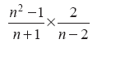 **(2)**

*y*

*x*

Graph **A**

*y*

*x*

Graph **B**

*y*

*x*

Graph **C**

*y*

*x*

Graph **D**

The graphs of *y* against *x* represent four different types of proportionality.

Write down the letter of the graph which represents the type of proportionality.

|  |  |
| --- | --- |
| **Type of proportionality** | **Graph letter** |
| *y* is directly proportional to *x* | ......................... |
| *y* is inversely proportional to *x* | ......................... |
| *y* is proportional to the square of *x* | ......................... |
| *y* is inversely proportional to the square of *x* | ......................... |

**(Total 2 marks)**