Chat with Big Ed

### Task 1: PREDICT

With a partner, spend time reading the code below. PREDICT exactly what you think will happen. This is not a test, so don’t worry about your prediction being correct.

|  |  |
| --- | --- |
|  |  |

What do you PREDICT will happen when the **Green flag** is clicked?

|  |  |
| --- | --- |
| **Questions** | **Your answers** ▿ |
| Now run the code.   * Were your predictions correct? |  |
| * Did anything surprise you about what happened when the code was executed? |  |
| * Did you miss anything out? If so, what? |  |

### Task 2: INVESTIGATE

Open the following Scratch program and select **See inside**

[ncce.io/biged1](https://ncce.io/biged1)

Answer the following questions with your partner by experimenting with the code in order to investigate how it works.

|  |  |
| --- | --- |
| **Questions** | **Your answers** ▿ |
| How do the following two blocks of code relate to each other? |  |
| Temporarily remove the following block:    What has this changed about the program when you run it?    Why do you think this is? |  |
| Below **define ask_name**, there are two **variables** being used. What are their names? |  |
| Now place the **ask what is your name and wait** block back into the code, but place it after the **set name to answer** block:    Why do you think it only says “Hello” and not “Hello “ and the name you entered?  What can you learn from this? |  |

### 

### Task 3: Modify

Now that you have explored how the game works, your task is to complete the parts of the program that aren’t currently working.

### 3.1: The music question

All of the code needed to make Big Ed ask about your favourite music has been included in the program. Place the blocks on the right-hand side into the appropriate places in the subroutine.

|  |  |
| --- | --- |
|  |  |

|  |  |
| --- | --- |
| **Questions** | **Your answers** ▿ |
| When you have completed your code, take a screenshot, and place it in the box to the right. |  |
| Errors in your code are known as ‘bugs’. The task of fixing these errors is known as ‘debugging’.  Did your code work the first time?  If anything didn’t work:   * Explain what didn’t work * How did you debug the errors? |  |

### 3.2: The age question

Complete the ask_age subroutine. The subroutine has two lines of code provided. The subroutine should use the age variable to store the answer. Big Ed should then say the following two lines:

“Wow [age]” for 2 seconds

“Your monster is much older than me in the year 2182” for 2 seconds

**Hint: Use the same structures from the previous two questions to build this question.**

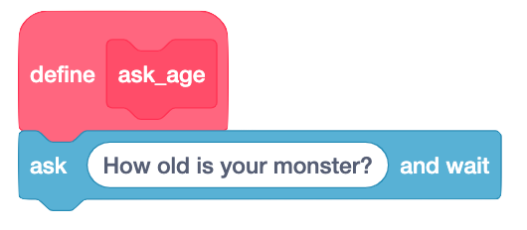

|  |  |
| --- | --- |
| **Questions** | **Your answers** ▿ |
| When you have completed your code, take a screenshot and place it in the box to the right. |  |
| Did your code work first time?  If anything didn’t work:   * Explain what didn’t work * How did you debug the errors? |  |

### Explorer task

Use the code blocks to add a new question to be asked about your favourite sport or hobby.

Resources are updated regularly — the latest version is available at: [ncce.io/tcc](http://ncce.io/tcc).

This resource is licensed under the Open Government Licence, version 3. For more information on this licence, see [ncce.io/ogl](http://ncce.io/ogl).