You’re hired

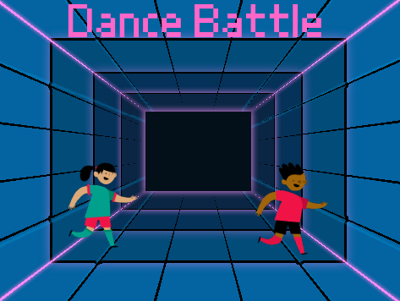
Introduction
A games development company has seen your ‘Moves like Jim’ game, and want to hire you to create a new game called ‘Dance battle’.

The company wants to help you develop your skills by giving you more training. Complete the table below to help them gain an understanding of your current programming skills.

Q1. Tick the boxes that apply to you:

Programming skills/concept | I don’t know what this is or how to use it | I know what this is, but would need support being able to use it | I am confident I know how to use this in a program
Place blocks in a sequence
Use variables
True or false conditions
Selection (If statements)
Operators (logic and comparison)
Count-controlled iteration (loops)

Q2: What do you think is your biggest achievement with the programs that you have made? What skills have you learnt throughout the programming unit that you have just completed at school?
Q3. Before you start working for us, what skills or programming concepts do you think you need to spend the most amount of time on?

Resources are updated regularly — the latest version is available at: ncce.io/tcc.

This resource is licensed under the Open Government Licence, version 3. For more information on this licence, see ncce.io/ogl.

