**Context** 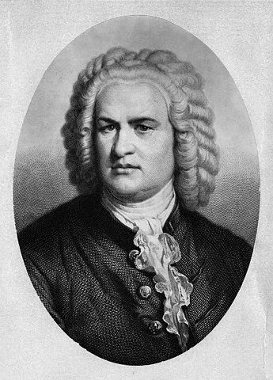

**J S Bach: 3rd Movement from Brandenburg Concerto no.5 in D major**

**Tempo, metre and rhythm**

**Harmony**

**Tonality**

**Performing forces (Instruments)**

**Structure**

**Texture**

**Dynamics**

**Melody**