Guess who
Use the worksheet to evaluate the conditions and decide which characters to remove from the game until you have a winner.
Cross out the characters with an X when you think they should be removed (i.e if they are told to disappear)
Statement No. | True or false | Characters to keep or remove
1 |  | 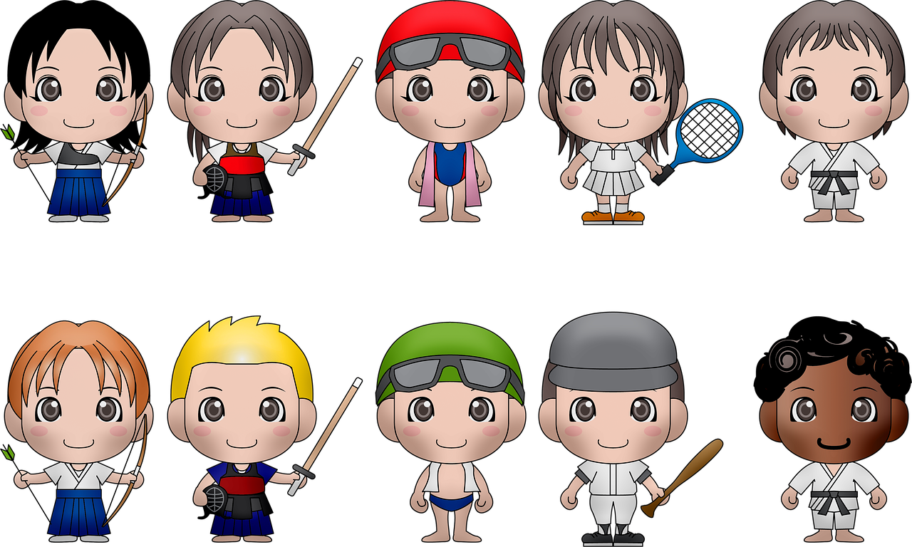
2
3
4
Resources are updated regularly — the latest version is available at: ncce.io/tcc.
This resource is licensed under the Open Government Licence, version 3. For more information on this licence, see ncce.io/ogl.

