Name: Class:

Starter
1. An engineer requires 100 m of steel cable.
(a) How could this be represented in:
(i) millimetres?

(ii) centimetres?

(b) Explain what happens to the place value of each digit in your answers above in order to convert from metres to cm and mm.

2. The average weight of a member of a user group is 68.54 kg.
Round this figure to the nearest whole number.

Explain how you rounded the number above.

Task 1
1. Calculate the following:
(a) A student has turned an aluminium tube to an external diameter of 8.45 mm.
Write this figure to 1 d.p.

(b) A teak garden bench has a mass of 30.78 kg. Write the mass to 1 d.p.

(c) A bag of 500 buttons have a total mass of 235.78 g. Work out the average
mass of a button to 2 s.f.

2. A blow moulding machine produces 1200 biodegradable plastic bottles per hour.
The costs and materials for each hour of manufacture are listed below:
- Running costs: £31
- Mass of polymer needed: 21.45 kg
- Volume of polymer needed: 45.47 litres
Based on these figures:
(a) Calculate the running costs per bottle. Give your answer to 2 d.p.

(b) Calculate the mass of polymer per bottle in grams. Give your answer to 2 d.p.

(c) Calculate the volume of polymer per bottle in millilitres. Give your answer to 2 s.f.

3. A family car produces 250 g of CO₂ per km. The car travels 150 km per week on average.
Calculate the total mass of CO₂ produced per year (365 days in a year) by the car. Give your answer in kilograms to 3 s.f.

Task 2
1. Express the following numbers in standard form.
(a) A steel bar with a mass of 156,700 g

(b) A volume of epoxy resin of 0.0045 m³

2. Express the following standard form numbers as ordinary numbers.
(a) An aircraft has wings with a span of 3.58 × 10⁴ mm

(b) The aircraft travels at 9.6 × 10² km/hour

3. The diagram shows a flexible solar cell.
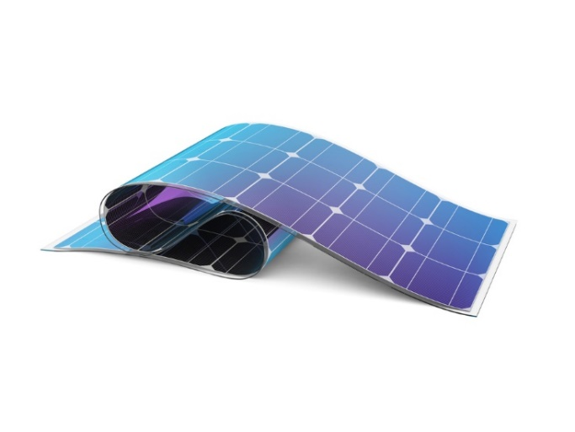
In each square cell, there is a thin wafer of silicon semi-conductor.
The squares have a length of 15 cm and a thickness of 0.25 mm.
Convert both dimensions above into metres. Express both dimensions in standard form.

